USER GUIDE CAMERA GLASS

# Description

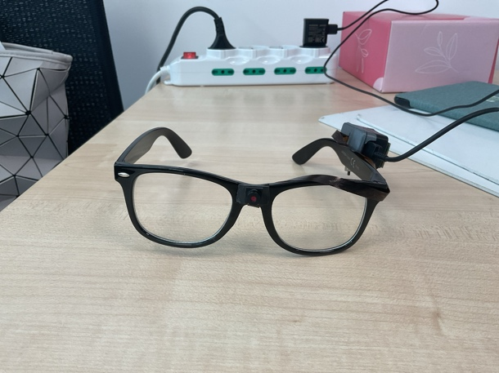This Guide show the fabrication and the functionalities of our camera glass device. This device works both by Wi-Fi and Bluetooth (with links with IM-TWIN and ECHO Android Appication) and the firmware is available at the following GitHub page <https://github.com/giampierobartolomei/Camera_Glass>.

The code used is partially modified from [Original Code Repo](https://github.com/s60sc/ESP32-CAM_MJPEG2SD). This repo is costantly updated, so in the future can be used for troubleshooting and for adding new features.

Stl file is ispired by [OpenGlass](https://github.com/BasedHardware/OpenGlass).

# Bill of Materials

|  |  |  |
| --- | --- | --- |
| Material | Cost | Link |
| LP502030-PCM-LD/3.7V 250mAh LI-ION POLYMER BATTERY | 8.99 Euro | <https://amzn.eu/d/fRJ3vzB> |
| 3D printed case | N/A | [GitHub](https://github.com/giampierobartolomei/Camera_Glass) |
| 20CM length OV2640 2 million pixels 66 degrees camera module | 4.69 Euro | [AliExpress](https://it.aliexpress.com/item/1005004670289539.html?src=google&pdp_npi=4@dis!EUR!4.69!4.69!!!!!@!12000030047068880!ppc!!!&src=google&albch=shopping&acnt=272-267-0231&isdl=y&slnk=&plac=&mtctp=&albbt=Google_7_shopping&aff_platform=google&aff_short_key=UneMJZVf&gclsrc=aw.ds&&albagn=888888&&ds_e_adid=&ds_e_matchtype=&ds_e_device=c&ds_e_network=x&ds_e_product_group_id=&ds_e_product_id=it1005004670289539&ds_e_product_merchant_id=109211432&ds_e_product_country=IT&ds_e_product_language=it&ds_e_product_channel=online&ds_e_product_store_id=&ds_url_v=2&albcp=20705056984&albag=&isSmbAutoCall=false&needSmbHouyi=false&gad_source=1&gbraid=0AAAAAoukdWNoL17o7fAJplJ7qB8a5TdBJ&gclid=CjwKCAiA2JG9BhAuEiwAH_zf3rouvPF3KxE00QSjF76YsPCjw2kG5WVqqPyXI3o1WDTSkx5Pw9ibFxoCiVIQAvD_BwE) |
| Solder, Wires, 1 switch, bioadhesive tape 3M and super attack | N/A | N/A |
| Xiao ESP32S3 Sense Module | 15 Euro | [AliExpress](https://it.aliexpress.com/item/1005007598922725.html?pdp_npi=4@dis!EUR!13.69!13.69!!!100.88!100.88!@212a65a717387057013297085d111f!12000041451018849!affd!!!&dp=CjwKCAiA2JG9BhAuEiwAH_zf3ogYDZnkIgsZxtqDq7Icw-uv2r_1mToMyWSG9MXS6uxvhKoLJdHcNhoC3xwQAvD_BwE&gad_source=1&gbraid=0AAAAADihhqU4HcLVNh9mD8oWdHLseg43X&gclid=CjwKCAiA2JG9BhAuEiwAH_zf3ogYDZnkIgsZxtqDq7Icw-uv2r_1mToMyWSG9MXS6uxvhKoLJdHcNhoC3xwQAvD_BwE&aff_fcid=8b16b4f852b04af4ada2ad1faa423efa-1738843874940-09276&aff_fsk&aff_platform=api-new-product-query&sk&aff_trace_key=8b16b4f852b04af4ada2ad1faa423efa-1738843874940-09276&terminal_id=f4742427721942f1ab15691ba183b4d8&afSmartRedirect=y) |

# Device Fabrication

Follow these simple steps:

1. Download And 3D print stl or gcode from the GitHub repo.
2. Manage the Wires as follows in the pictures

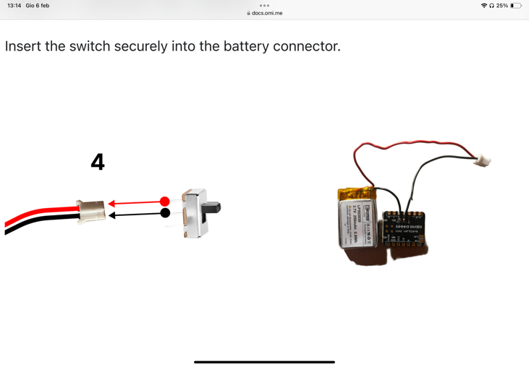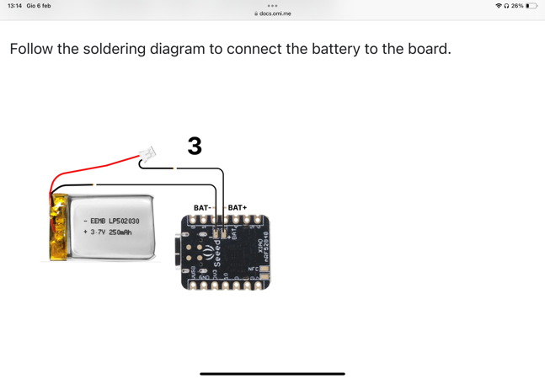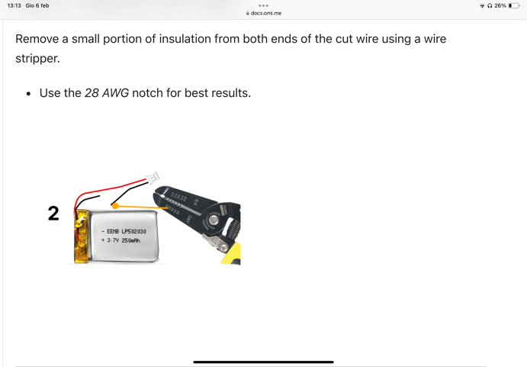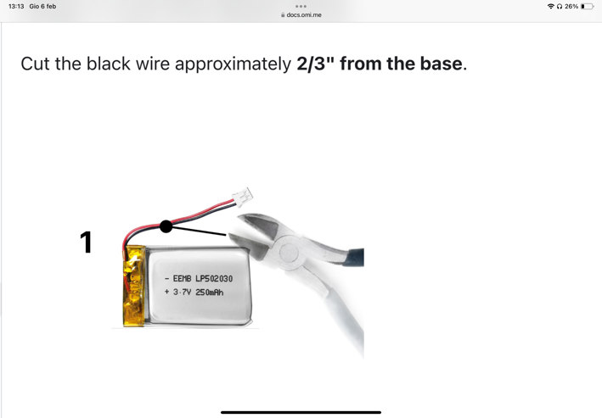

1. 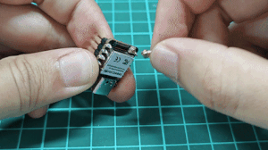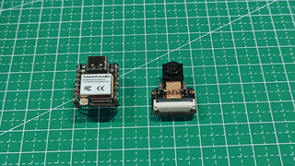Now take the module and install the antenna, the espansion board and the right ov2640 camera (200 mm). Then insert a microSD (FAT32!). These steps and some of the next are also explained [Here](https://wiki.seeedstudio.com/xiao_esp32s3_getting_started/). This page shows the complete guide for first use and can be useful for troubleshooting.
2. Clone the repository and copy the ‘data’ folder (CameraGlass/ESP32-CAM_MJPEG2SD/data) on the microSD. Then Connect the device to a computer and load the .ino code with Arduino Uno taking care of these requirements: Espressif Core version 3.1.1 ([Installation Guide](https://docs.espressif.com/projects/arduino-esp32/en/latest/installing.html)), PSRAM active (Arduino uno tool bar -> Tools -> PSRAM > "OPI_PSRAM", Tools -> Partition Scheme -> 3 MB APP. If you have some trouble uploading the code (check loading blink Example from Arduino) disconnect the device, press and hold Boot button and while doing it reconnect the device to the computer and finally release the button.
3. Use a bioadhesive tape to glue the center of a glass and the retro of the ov2640 camera and use attack to glue these two piece of tapes. Color with a black Pencil the camera strip and made it pass over the left stick securing it with a black tape. Then use the same method as before tu glue the cap of the case to the stick, without closing the hole for camera strip. Put the battery on the case, take out from the hole antenna and switch cables and secure the antenna with biohadesive tape (without using extra glue). Finally insert the camera module, with usb-port next to the biggest hole and close by pressing the case on the cap.

# First Use

On first installation, the application will start in wifi AP mode - connect to SSID: ESP-CAM_MJPEG_..., to allow router to be selected and router password entered via the web page on 192.168.4.1. The configuration data file (except passwords) is automatically created, and the application web pages automatically downloaded from GitHub to the SD card /data folder when an internet connection is available.

At this point the interface allows you without modify the code to: decide Video Settings, DISABLE MOTION DETECT!! (this setting autorecord when recognize a movement, disable it in first use and save settings), Start a stream to check the video recording, start manually the recording and finally have access to SD memory in order to see or delete files. In settings, you can also put the SSID and password of your Wi-Fi and a new IP address for connecting from your Wi-Fi is created.

# Computer vision data settings

In order to process the recorded video with computer vision program follow these steps:

1. From the web page in video settings put & save: SVGA (600X800) 20 fps 4 quality.
2. Record the video, and it will be saved in the microSD card.
3. Save the file on the computer and run this command on the same directory: 'ffmpeg -i input.avi -c:v libx264 -crf 23 -preset medium -c:a aac -b:a 128k output.mp4'. This Line convert .avi file to .mp4 mantaining quality and fps.
4. A test with a 3 minutes video, where manual labelling were compared with our CNN output reported a K-Cohen of 0.785.

# How to record videos

There are three ways to record and save video:

1. Web App: click on Record button. Through start/stop stream you can also see in real time your recording.
2. Via smartphone: Download nRF Connect, Connect to ‘CameraModule’ and send these UTF8 string to respectively start and stop recordings: ‘rec’, ‘stp’.
3. Echo or IM-TWIN Android App: After connecting the TWC device, click on ‘Camera’ button. Once the device is connected, this button will become green. Then use the Rec button to start/stop a video. If camera is connected, Start log button will simultaneosly start the recording of the toy data and the video recording from the Camera Glasses.

# Charging the Device

In order to charge the device, connect a usb-c cable to the device and turn it ON!. When charging, inside the cable hole you can see a red led blinking. When the device is charged red light will turn off. (Orange Led turns on with the device supply.)

# 8. Device Updates

Since the Wifi connection shows a lot of problems, now device works with only BT functionalities, and you can also read the battery voltage from the command characteristic sended by the device every 10 seconds! (use nRf connect and set UTF-8 datatype).